PixelBot Simulator User Guide

When launched the program creates a number of dialog windows:- PixelBot Simulator, Script Manager, Robot Manager and a Console.

The simulator windows is created using PyGame but the rest are created with tkinter.

The Simulator window is the ARENA in which the graphics are rendered. The size of the ARENA is defined in Constants.py as is the simulated distance sensor range (see yellow cone below).

If two robots come within sensor range a line is drawn between their centres. If the robots collide a red line is drawn. Both colors can be configured via Constants.py

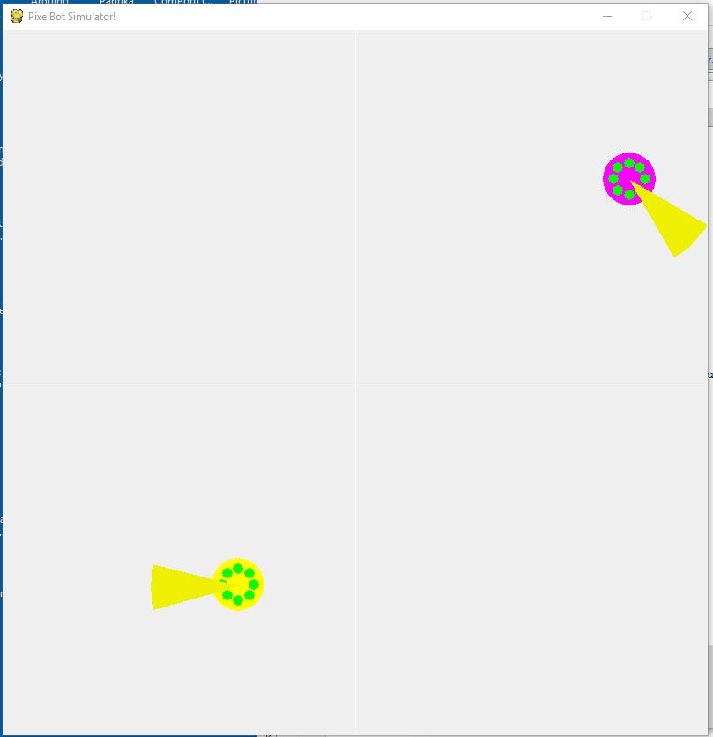

The script Manager allows you to open/edit/save robot scripts.

You can also send the current script to an active robot or all selected robots. The dialogs’ primary purpose is for script development. Closing the Script manager window closes the program.

You must remember to save the script to a file as it isn’t automatically saved when the program ends.

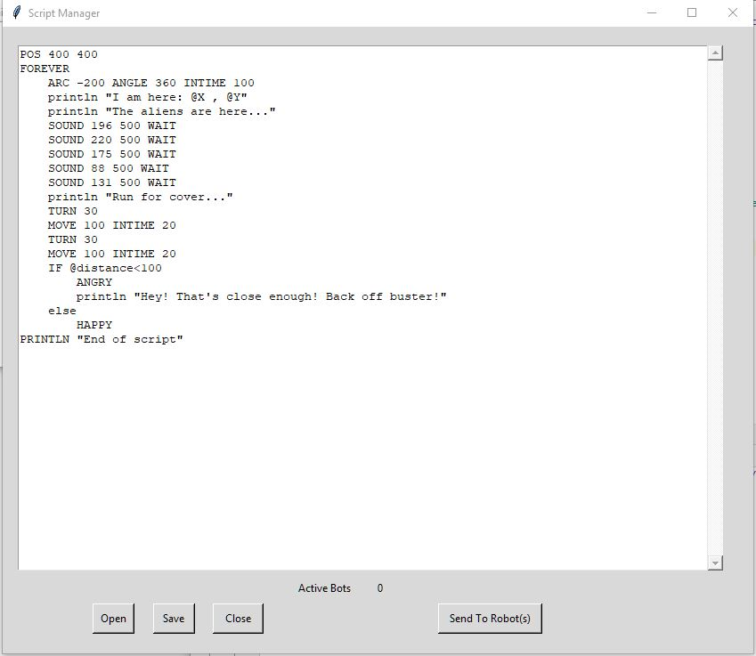

The Robot Manager dialog lets you activate robots – they then appear in the simulator window at a random location and will run their scripts automatically.

To remove a robot from the arena you click the delete key.

If you select multiple robots the Delete and Activate buttons will work on all the selected robots

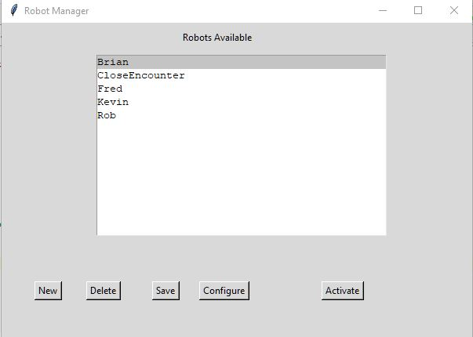

The save button creates a backup of the current robot.json file and writes the current configurations out to a new JSON file.

Pressing the configure button opens a configuration dialog which lets you reconfigure your selected robot.

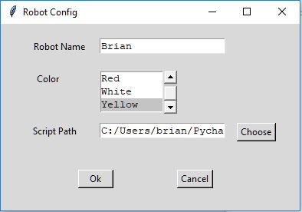

After changing the configuration click the Save button in the Robot manager dialog otherwise your changes will be lost.

The Console dialog is where robot print commands are displayed. The output is prefixed by the name of the robot to reduce confusion.

